RESOLUTION NO.__________

RE: CERTIFICATE OF APPROPRIATENESS UNDER THE
PROVISIONS OF THE ACT OF THE PENNSYLVANIA
LEGISLATURE 1961, JUNE 13, P.L. 282 (53
SECTION 8004) AND BETHLEHEM ORDINANCE NO.
3952 AS AMENDED.

WHEREAS, it is proposed to remove the rear chimney, install storm windows on stained glass windows, paint the trim, replace roof shingles, erect a fence in the rear yard and close off two windows at 129 E. Market St.

NOW, THEREFORE, BE IT RESOLVED by the Council of the City of Bethlehem that a Certificate of Appropriateness is hereby granted for the proposal.

Sponsored by: (s)

(s)

ADOPTED BY COUNCIL THIS DAY OF

(s)
President of Council

ATTEST:

(s)
City Clerk

HISTORICAL & ARCHITECTURAL REVIEW BOARD

APPLICATION #1: The applicant proposes to remove the rear chimney, install storm windows on stained glass transoms, paint exterior trim, replace roof shingles, install a wooden fence in the rear yard and close two windows at 129 E. Market St.

OWNER: Bruce & Kim Campbell
129 E. Market St., Bethlehem, PA 18018
__________________________________________________________________

The Board upon motion by Marsha Fritz and seconded by Holly Sachdev adopted the proposal that City Council issue a Certificate of Appropriateness for the following:

- Remove below the roof plane the rear inactive chimney, close the opening and shingle with GAF Slateline shingles in Antique Slate color.

- Install storm windows on existing stained glass transoms throughout the house and suggested to consider interior storm panels on the transoms and a system that incorporates a metal strip on the sash with a magnetic strip on the storm panel.

3. Repaint the exterior trim with Valspar Paint Company #7006-16 Mystique.

4. Remove existing roof and replace with GAF Slateline in Antique Slate color.

5. Install a 6 ft. high fence constructed of cedar and stained with an Opaque stain in
Black Forest Green Benjamin Paint color.

6. Closing two side windows openings from the inside. The outfacing surface of the
interior closure to be painted flat black.

7. The motion was unanimously approved.

__________________________________________________________________________

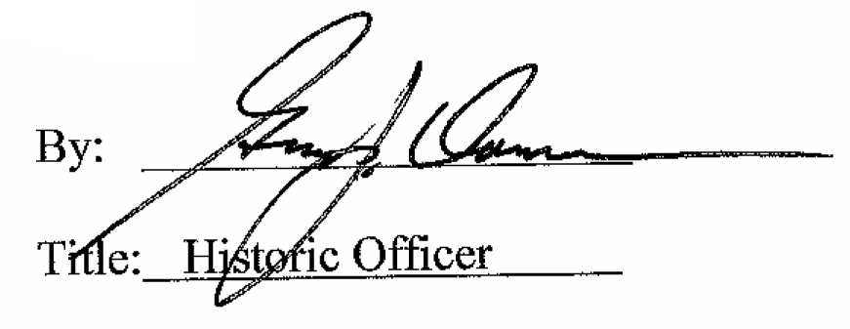

Date of Meeting: December 3, 2014

